The oldest medical consent form has been uncovered – it comes way back from 1524

April 6, 2015 11:43 am by Nicole Oran
Long before the written consent form was adopted in the West, it was apparently in practice in the 16th Century Ottoman Empire, according to some Turkish historians.
It wasn’t until the 1947 Nuremberg Code and a 1957 medical malpractice suit that introduced the term “informed consent” that the practice entered into the legal lexicon in the U.S., but apparently the concept had been established long ago. Nearly 500 years ago, in fact.
Omur Sayligil and Hilmi Ozdenb of Turkey’s Eskisehir Osmangazi University recently published their new study exploring the documentation, specifically from a patient giving permission to remove a bladder stone, in the journal Annals of Saudi Medicine.
The historians found the written consent form in Qadi registers. These are documents used by historians studying the Ottoman Empire’s medical past.
The images and information about the discovery were shared by io9.
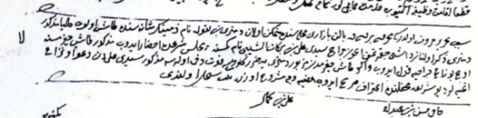
In English, the document reads:
“This is written to certify that Dimitri bin nikola, a dhimmi (a non-Muslim living in the Ottoman State), resident in the Bal?kpazar? neighborhood of the city of Bursa, who has a stone in his bladder, presented with Surgeon cerrah Seydi? Ali bin Bereka?t es-Seybi? to the court hearing to have the stone removed, agreeing in the Sharia court in the presence of the qadi that he would pay 300 akc?e (silver coins) for the removal of stone and that Seydi Ali would not be sued if Dimitri is harmed or even loses his life due to the stone removal.” Witnesses: hac? hasan bin Abdullah Ali bin Kemal (Date: 26 Dhu al-Qi’dah 933)
During the early part of the 19th century, doctors were willing to lie to patients because those receiving care weren’t considered to have enough of an understanding to deal with whatever information they might get. But the notion of consent and transparency has thankfully now become the norm. It is fascinating to know, as the authors point out, that the Western world was behind on this concept, though.

